

Sem 2 Examination 2015

Question/answer booklet

YEAR 10A
Name: __________________________________________

Teacher: __________________________________________
EXTENSION
MATHEMATICS

Section One:
Calculator-free

Time allowed for this section
Section One
Reading time before commencing work: 2 minutes
Working time for paper: 28 minutes

Material required/recommended for this paper

To be provided by the supervisor
This question/answer Booklet
Formula sheet

To be provided by the student
Standard items: pens, pencils, pencil sharpener, eraser, correction fluid/tape, ruler, highlighter

Standard items: nil

Important note to students

This test comprises of TWO sections. The first section is calculator free where no calculators of any kind are to be used. The second section is calculator assumed where a scientific calculator may be used. All questions must be answered in both sections. Answers should be rounded appropriately. All working should be shown in the space provided. Your working should be in sufficient detail to allow your answers to be checked readily and for marks to be awarded for reasoning. Incorrect answers given without supporting reasoning cannot be allocated any marks. For any question or part question worth more than two marks, valid working or justification is required to receive full marks.

No pen, pencils, highlights etc. may be used during reading time. This time is to be used to read through the assessment and check that you understand what is being asked of you. You may speak with the teacher/supervisor during this time (by putting up your hand and waiting patiently for them to approach you) but you may only ask clarification questions and not how to solve the problems. After this reading time has ended, you may not ask any more questions.

Instructions to students

1. Write your answers in the spaces provided in this Question/Answer Booklet. Spare pages are included at the end of this booklet. They can be used for planning your responses and/or as additional space if required to continue an answer.
  - Planning: If you use the spare pages for planning, indicate this clearly at the top of the page.
  - Continuing an answer: If you need to use the space to continue an answer, indicate in the original answer space where the answer is continued, i.e. give the page number. Fill in the number of the question(s) that you are continuing to answer at the top of the page.

2. Show all of your working clearly. Your working should be in sufficient detail to allow your answers to be checked readily and for marks to be awarded for reasoning. Incorrect answers given without supporting reasoning cannot be allocated any marks. For any question or part question worth more than two marks, valid working or justification is required to receive full marks. If you repeat an answer to any question, ensure that you cancel the answer you do not wish to have marked.

3. It is recommended that you do not use pencil except in diagrams.

MARK ALLOCATION AND RECORDS:

Section | Question | Marks | Awarded
ONE | 1 | 3
 | 2 | 5
 | 3 | 4
 | 4 | 3
 | 5 | 5
 | 6 | 2
 | 7 | 2
 | 8 | 3
 | ONE | 27 |  |  | %
 | TWO | 33 |  |  | %
 | TOTAL | 60 |  |  | %

Question 1 (3 marks: 1, 2)

Simplify the following
a) $\sqrt{500}$ f) $\log_{7}{4}+\log_{7}{12}-\log_{7}{3}$

Question 2 (5 marks: 1, 2, 2)
Simplify the following, leaving your answers with positive indices, or evaluate.

a) $2^{8}×2^{11}$ b) $\frac{64a^{4}y^{2}z^{2}}{16a^{5}y^{3}}$

f) $5^{2}+(x^{5}+{5)}^{0}$

Question 3 (4 marks: 2, 2)
Expand and where possible, simplify the following
a) $p(p-3)$ c) ${(q+5)}^{2}$

Question 4 (3 marks: 1, 2)
Rationalise the denominator in the following
a) $\frac{4}{\sqrt{7}}$ b) $\frac{\sqrt{6}}{\sqrt{2}}$

Question 5 (4 marks: 2, 3)

For the equation

a) Complete the table of values for

b) Plot the function on the axes below; (use 3 squares for one unit on the $x$ axis)
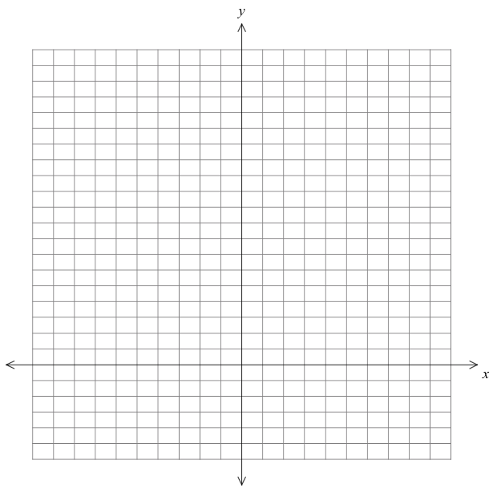

Question 6 (2 marks: 1, 1)
Evaluate the following
a) $\log_{2}{32}$ b) $\log_{5}{125}$

Question 7 (2 marks)
Solve this set of simultaneous equations
$$y=3x-7 \\ y=3-2x$$

Question 8 (3 marks: 1, 2)
Solve the following
a) $2^{x}=64$ b) $3^{x-1}=81$

End of Section One

Spare page

